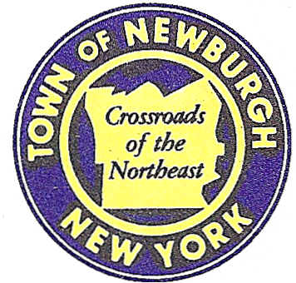

TOWN OF NEWBURGH
_______Crossroads of the Northeast __________________________
OLD TOWN HALL
308 GARDNERTOWN ROAD NEWBURGH, NEW YORK 12550

PLANNING BOARD
JOHN P. EWASUTYN, CHAIRMAN
TELEPHONE 845-564-7804
FAX 845-564-7802
E-MAIL: planningboard@townofnewburgh.org

PLANNING BOARD AGENDA

MARCH 19, 2015

*PLEASE NOTE: The Planning Board Meeting will start at 7:00 P.M. and all Applicants/Representatives
are to be present at that time. The Meeting will be held in the Meeting Room of Town Hall,
located at 1496 Route 300, Newburgh NY.*

- NYC DEP Delaware Aqueduct Repair (2011-15)  Roundout-West Branch Tunnel  Sec. 8; Blk. 1; Lot 15.2 & 22.2  Zone: B/AR  Rep: NYC DEP  96-05 Horace Harding Exp.  Corona, NY 11368 | AMENDED SITE PLAN
- Kozlowski Subdivision (2015-04)  254 Quaker Street  Section 2, Block 1, Lot 9  Zone: AR  Rep: Talcott Engineering  1 Gardnertown Road  Newburgh, NY 12550 | 3 LOT SUBDIVISION  PUBLIC HEARING
- Hudson Valley Chrysler Dodge Jeep Ram (2015-01)  200 Auto Park Place  Section 97, Block 2, Lot 11.2  Zone: IB  Rep: John Meyer Consulting  120 Bedford Road  Armonk, NY 10504 | SITE PLAN
- Golden Vista/Meadow (1999-33)  Meadow Hill Road  Section 60, Block 1, Lot 9.1  Zone: R-3  Rep: John Meyer Consulting  120 Bedford Road  Armonk, NY 10504 | AMENDED SITE PLAN  CONCEPT
- Dunkin Donuts (2014-02)  301 NYS Route 32  Section 14, Block. 1, Lot 43  Zone: IB  Rep: Joseph Minuta  Minuta Architecture  554 Temple Hill Road  New Windsor, NY 12553 | SITE PLAN

*WORK SESSION: Project Readiness Discussion scheduled for 5:30 p.m. in the Meeting Room of Town Hall on Thursday, March 19, 2015*

PLANNING BOARD BUSINESS
WORK SESSION

March 19, 2015
5:30 P.M.

Discussion:

